Cloud Computing

What is Cloud Computing?
Cloud Computing is a model for enabling ubiquitous, convenient, on-demand network access to a shared pool of configurable computing resources (e.g., network, storage, servers, applications and services) that can be rapidly provisioned and released with minimal management effort or service provider interaction.

Cloud Service Models
Types of Cloud Computing
Cloud computing services are classified into five main types, collectively known as the cloud computing stack:
- Software as a service (SaaS)
- Platform as a service (PaaS)
- Infrastructure as a service (IaaS)
- Anything/Everything as a Service (XaaS)
- Function as a Service (FaaS)
1. Software as a Service(SaaS)
Software as a Service (SaaS) is a cloud computing model in which software applications are delivered over the internet and accessed through a web browser, eliminating the need for local installation, maintenance, or updates. The service provider manages the application, infrastructure, and security, while users pay on a usage or subscription basis.
- Accessible through a web browser
- Pay-as-you-go or subscription-based pricing
- Can be accessed anytime, anywhere
- Also known as web-based or on-demand software
Example: Google Docs is a SaaS application where users can create and edit documents online without installation, while Google handles storage and updates.

Advantages
- Cost-effective: Pay only for the services used.
- Quick deployment: No installation or configuration required.
- High accessibility: Data can be accessed from any device with internet.
- Automatic updates: Updates are handled by the provider.
- Scalable: Resources and features can be adjusted on demand.
Disadvantages
- Limited customization: Less flexibility compared to on-premises software.
- Internet dependency: Requires a stable internet connection.
- Security risks: Potential risk of data breaches.
- Reduced data control: Data is managed by the service provider.
Popular SaaS Providers: Salesforce, Microsoft Office 365, Google Workspace, Dropbox, BigCommerce, Zoho, Slack.
2. Platform as a Service
Platform as a Service (PaaS) is a cloud computing model that provides developers with a ready-to-use platform for building, testing, deploying, and managing applications without worrying about underlying hardware, operating systems, or infrastructure. The service provider manages servers, storage, and runtime environments, allowing developers to focus only on application logic.
- Accessed through a web browser
- Backend infrastructure is managed by the provider
- Developers control the application and its behaviour
Example: PaaS is like renting a fully equipped venue for an event—basic setup is already done, so you can concentrate on organizing the event. Similarly, developers focus on coding while the provider handles backend infrastructure.
Advantages
- Simple and convenient: No infrastructure management required.
- Cost-effective: Pay only for resources used.
- Full lifecycle support: Helps in building, testing, deploying, and updating applications.
- Higher efficiency: Reduces development complexity and time.
Disadvantages
- Limited infrastructure control: Restricted customization options.
- Provider dependency: Availability and reliability depend on the vendor.
- Limited flexibility: Not suitable for all application types.
Popular PaaS Providers: AWS Elastic Beanstalk, Google App Engine, Azure App Service, Salesforce Platform (Force.com), CloudBees, IBM Cloud
3. Infrastructure as a Service
Infrastructure as a Service (IaaS) is a cloud computing model in which virtualized computing resources such as servers, storage, and networking are provided over the internet on a rental basis. The cloud provider manages the physical infrastructure, while users control the operating system, applications, and data.
- Provides virtual machines, storage, and networking
- Pay-as-you-use pricing model
- Users have full control over OS and applications
Example: IaaS is like renting a server instead of buying one. You use the provider’s hardware and network, but you decide what software or website runs on it.
Advantages
- Cost-effective: No need to buy physical hardware.
- Flexible hosting: Suitable for websites and applications.
- Reduced maintenance: Provider manages data centers and hardware.
- Scalable: Resources can be increased or decreased as needed.
Disadvantages
- Security responsibility: Users must secure their own data and apps.
- Limited infrastructure control: Physical infrastructure is provider-managed.
- Regional limitations: Availability may vary due to legal or policy issues.
Popular IaaS Providers: Amazon Web Services (AWS), Microsoft Azure, Google Cloud, IBM Cloud, Rackspace, VMware.

4. Anything as a Service
Anything or Everything as a Service (XaaS) is a broad cloud computing model in which a wide range of IT services—including infrastructure, platforms, software, storage, security, and networking—are delivered over the internet on a pay-as-you-use basis. It represents the combination and extension of SaaS, PaaS, IaaS, and other cloud services.
Example: A company uses AWS for virtual servers (IaaS), Google Workspace for email and documents (SaaS), and Firebase for backend services (PaaS). Using all these services together is an example of XaaS.
Advantages
- Scalable: Services can be easily scaled as needed.
- Flexible: Offers a wide variety of on-demand services.
- Cost-effective: Users pay only for the services they consume.
Disadvantages
- Provider dependency: Service availability depends on the cloud provider.
- Limited flexibility: Some workloads may not be supported.
- Integration issues: Compatibility with existing systems can be challenging.
5. Function as a Service
Function as a Service (FaaS) is a cloud computing model that allows developers to run small pieces of code (functions) in response to events without managing servers or infrastructure. The cloud provider automatically handles resource allocation, scaling, and execution, and users pay only for the actual execution time.
Example: When a user uploads an image to a website, a function automatically resizes the image and stores it. This function runs only when triggered and stops after execution—this is FaaS.
Advantages
- No server management: Fully managed by the provider.
- Cost-efficient: Pay only when the function runs.
- Automatic scaling: Scales instantly based on demand.
- Fast deployment: Ideal for event-driven applications.

Disadvantages
- Cold start latency: Delay may occur when a function runs after being idle.
- Limited execution time: Not suitable for long-running tasks.
- Vendor dependency: Strong reliance on the cloud provider.

Cloud Deployment Model
Public Cloud
The public cloud makes it possible for anybody to access systems and services. The public cloud may be less secure as it is open to everyone. The public cloud is one in which cloud infrastructure services are provided over the internet to the general people or major industry groups. The infrastructure in this cloud model is owned by the entity that delivers the cloud services, not by the consumer. It is a type of cloud hosting that allows customers and users to easily access systems and services. This form of cloud computing is an excellent example of cloud hosting, in which service providers supply services to a variety of customers. In this arrangement, storage backup and retrieval services are given for free, as a subscription, or on a per-user basis. For example, Google App Engine etc.
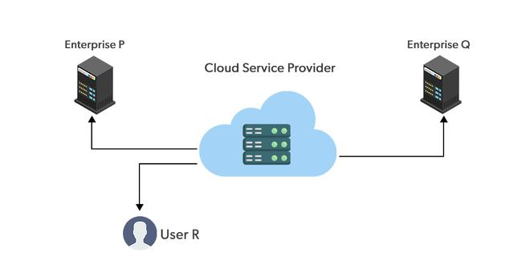Public Cloud

Advantages of the Public Cloud Model
- Minimal Investment: Because it is a pay-per-use service, there is no substantial upfront fee, making it excellent for enterprises that require immediate access to resources.
- No setup cost: The entire infrastructure is fully subsidized by the cloud service providers, thus there is no need to set up any hardware.
- Infrastructure Management is not required: Using the public cloud does not necessitate infrastructure management.
- No maintenance: The maintenance work is done by the service provider (not users).
- Dynamic Scalability: To fulfill your company's needs, on-demand resources are accessible.
Disadvantages of the Public Cloud Model
- Less secure: Public cloud is less secure as resources are public so there is no guarantee of high-level security.
- Low customization: It is accessed by many public so it can't be customized according to personal requirements.
Private Cloud
The private cloud deployment model is the exact opposite of the public cloud deployment model. It's a one-on-one environment for a single user (customer). There is no need to share your hardware with anyone else. The distinction between private and public clouds is in how you handle all of the hardware. It is also called the "internal cloud" & it refers to the ability to access systems and services within a given border or organization. The cloud platform is implemented in a cloud-based secure environment that is protected by powerful firewalls and under the supervision of an organization's IT department. The private cloud gives greater flexibility of control over cloud resources.
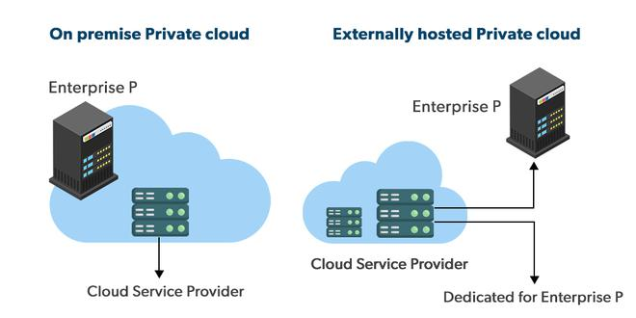Private Cloud
Advantages of the Private Cloud Model
- Better Control: You are the sole owner of the property. You gain complete command over service integration, IT operations, policies, and user behavior.
- Data Security and Privacy: It's suitable for storing corporate information to which only authorized staff have access. By segmenting resources within the same infrastructure, improved access and security can be achieved.
- Supports Legacy Systems: This approach is designed to work with legacy systems that are unable to access the public cloud.
- Customization: Unlike a public cloud deployment, a private cloud allows a company to tailor its solution to meet its specific needs.
Disadvantages of the Private Cloud Model
- Less scalable: Private clouds are scaled within a certain range as there is less number of clients.
- Costly: Private clouds are more costly as they provide personalized facilities.
Hybrid Cloud
By bridging the public and private worlds with a layer of proprietary software, hybrid cloud computing gives the best of both worlds. With a hybrid solution, you may host the app in a safe environment while taking advantage of the public cloud's cost savings. Organizations can move data and applications between different clouds using a combination of two or more cloud deployment methods, depending on their needs.
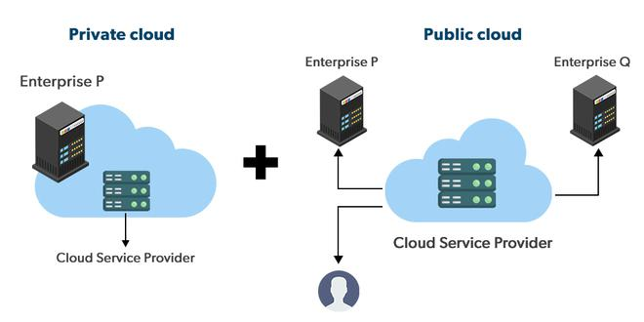Hybrid Cloud
Advantages of the Hybrid Cloud Model
- Flexibility and control: Businesses with more flexibility can design personalized solutions that meet their particular needs.
- Cost: Because public clouds provide scalability, you'll only be responsible for paying for the extra capacity if you require it.
- Security: Because data is properly separated, the chances of data theft by attackers are considerably reduced.
Disadvantages of the Hybrid Cloud Model
- Difficult to manage: Hybrid clouds are difficult to manage as it is a combination of both public and private cloud. So, it is complex.
- Slow data transmission: Data transmission in the hybrid cloud takes place through the public cloud so latency occurs.
Community Cloud
It allows systems and services to be accessible by a group of organizations. It is a distributed system that is created by integrating the services of different clouds to address the specific needs of a community, industry, or business. The infrastructure of the community could be shared between the organization which has shared concerns or tasks. It is generally managed by a third party or by the combination of one or more organizations in the community.
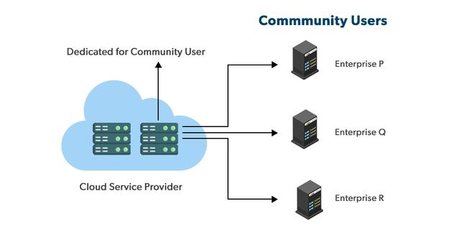Community Cloud
Advantages of the Community Cloud Model
- Cost Effective: It is cost-effective because the cloud is shared by multiple organizations or communities.
- Security: Community cloud provides better security.
- Shared resources: It allows you to share resources, infrastructure, etc. with multiple organizations.
- Collaboration and data sharing: It is suitable for both collaboration and data sharing.
Disadvantages of the Community Cloud Model
- Limited Scalability: Community cloud is relatively less scalable as many organizations share the same resources according to their collaborative interests.
- Rigid in customization: As the data and resources are shared among different organizations according to their mutual interests if an organization wants some changes according to their needs they cannot do so because it will have an impact on other organizations.
Multi-Cloud
We're talking about employing multiple cloud providers at the same time under this paradigm, as the name implies. It's similar to the hybrid cloud deployment approach, which combines public and private cloud resources. Instead of merging private and public clouds, multi-cloud uses many public clouds. Although public cloud providers provide numerous tools to improve the reliability of their services, mishaps still occur. It's quite rare that two distinct clouds would have an incident at the same moment. As a result, multi-cloud deployment improves the high availability of your services even more.
Multi-Cloud
Advantages of the Multi-Cloud Model
- You can mix and match the best features of each cloud provider's services to suit the demands of your apps, workloads, and business by choosing different cloud providers.
- Reduced Latency: To reduce latency and improve user experience, you can choose cloud regions and zones that are close to your clients.
- High availability of service: It's quite rare that two distinct clouds would have an incident at the same moment. So, the multi-cloud deployment improves the high availability of your services.
Disadvantages of the Multi-Cloud Model
- Complex: The combination of many clouds makes the system complex and bottlenecks may occur.
- Security issue: Due to the complex structure, there may be loopholes to which a hacker can take advantage hence, makes the data insecure.
What is the Right Choice for Cloud Deployment Model?
As of now, no such approach fits picking a cloud deployment model. We will always consider the best cloud deployment model as per our requirements. Here are some factors which should be considered before choosing the best deployment model.
- Cost: Cost is an important factor for the cloud deployment model as it tells how much amount you want to pay for these things.
- Scalability: Scalability tells about the current activity status and how much we can scale it.
- Easy to use: It tells how much your resources are trained and how easily can you manage these models.
- Compliance: Compliance tells about the laws and regulations which impact the implementation of the model.
- Privacy: Privacy tells about what data you gather for the model.

Cloud Computing Challenges

7 Most Common Cloud Computing Challenges

1. Data Security and Privacy
Data security is a major concern when switching to cloud computing. User or organizational data stored in the cloud is critical and private. Even if the cloud service provider assures data integrity, it is your responsibility to carry out user authentication and authorization, identity management, data encryption, and access control. Security issues on the cloud include identity theft, data breaches, malware infections, and a lot more which eventually decrease the trust amongst the users of your applications. This can in turn lead to potential loss in revenue alongside reputation and stature. Also, dealing with cloud computing requires sending and receiving huge amounts of data at high speed, and therefore is susceptible to data leaks.
2. Cost Management
Even as almost all cloud service providers have a "Pay As You Go" model, which reduces the overall cost of the resources being used, there are times when there are huge costs incurred to the enterprise using cloud computing. When there is under optimization of the resources, let's say that the servers are not being used to their full potential, add up to the hidden costs. If there is a degraded application performance or sudden spikes or overages in the usage, it adds up to the overall cost. Unused resources are one of the other main reasons why the costs go up. If you turn on the services or an instance of cloud and forget to turn it off during the weekend or when there is no current use of it, it will increase the cost without even using the resources.
3. Multi-Cloud Environments
Due to an increase in the options available to the companies, enterprises not only use a single cloud but depend on multiple cloud service providers. Most of these companies use hybrid cloud tactics and close to 84% are dependent on multiple clouds. This often ends up being hindered and difficult to manage for the infrastructure team. The process most of the time ends up being highly complex for the IT team due to the differences between multiple cloud providers.
4. Performance Challenges
Performance is an important factor while considering cloud-based solutions. If the performance of the cloud is not satisfactory, it can drive away users and decrease profits. Even a little latency while loading an app or a web page can result in a huge drop in the percentage of users. This latency can be a product of inefficient load balancing, which means that the server cannot efficiently split the incoming traffic so as to provide the best user experience. Challenges also arise in the case of fault tolerance, which means the operations continue as required even when one or more of the components fail.
5. Interoperability and Flexibility
When an organization uses a specific cloud service provider and wants to switch to another cloud-based solution, it often turns up to be a tedious procedure since applications written for one cloud with the application stack are required to be re-written for the other cloud. There is a lack of flexibility from switching from one cloud to another due to the complexities involved. Handling data movement, setting up the security from scratch and network also add up to the issues encountered when changing cloud solutions, thereby reducing flexibility.
6. High Dependence on Network
Since cloud computing deals with provisioning resources in real-time, it deals with enormous amounts of data transfer to and from the servers. This is only made possible due to the availability of the high-speed network. Although these data and resources are exchanged over the network, this can prove to be highly vulnerable in case of limited bandwidth or cases when there is a sudden outage. Even when the enterprises can cut their hardware costs, they need to ensure that the internet bandwidth is high as well there are zero network outages, or else it can result in a potential business loss. It is therefore a major challenge for smaller enterprises that have to maintain network bandwidth that comes with a high cost.
7. Lack of Knowledge and Expertise
Due to the complex nature and the high demand for research working with the cloud often ends up being a highly tedious task. It requires immense knowledge and wide expertise on the subject. Although there are a lot of professionals in the field they need to constantly update themselves. Cloud computing is a highly paid job due to the extensive gap between demand and supply. There are a lot of vacancies but very few talented cloud engineers, developers, and professionals. Therefore, there is a need for upskilling so these professionals can actively understand, manage and develop cloud-based applications with minimum issues and maximum reliability.

